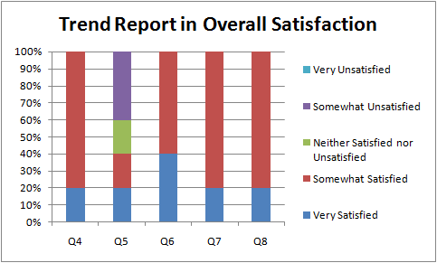
Viking Project – Customer Satisfaction Survey Data

No. | Question | Quality Requirement
Q1 | Customer Age
Q2 | Customer Gender
Q3 | How often do you use the Viking software? | Frequency
Q4 | How satisfied are you with your purchase experience?
Q5 | How satisfied are you with your installation experience?
Q6 | How satisfied are you with your user experience?
Q7 | How satisfied are you with your support experience?
Q8 | Overall, How satisfied are you with our software?

- Customer Age
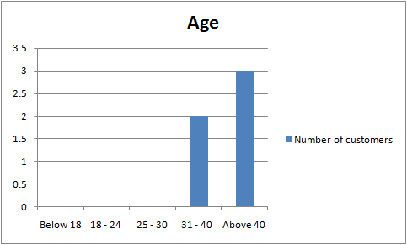
- Customer Gender
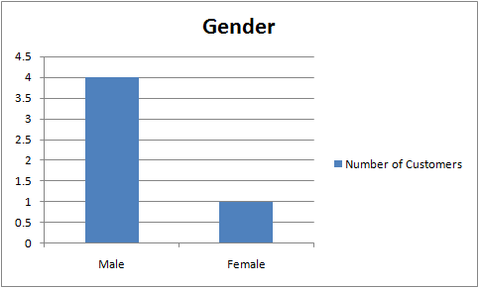

- How often do you use the Viking Software?
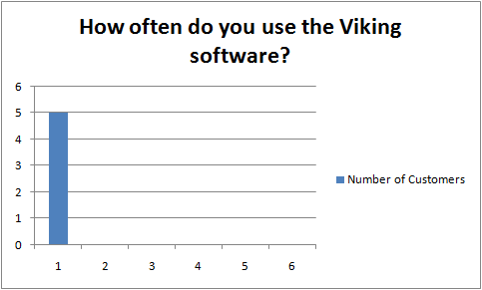
No. | Frequency | Number of Customers
1 | At least once per week | 5
2 | 2-3 times per month | 0
3 | Once per month | 0
4 | Once per quarter | 0
5 | Once per year | 0
6 | Do not use | 0

- How satisfied are you with your purchase experience?
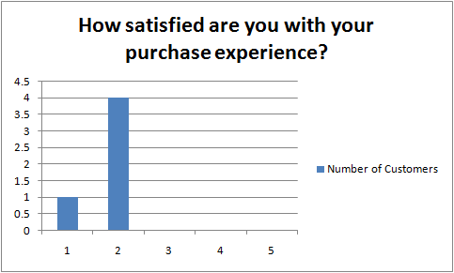
No. | Level of satisfied | Number of Customers
1 | Very Satisfied | 1
2 | Somewhat Satisfied | 4
3 | Neither Satisfied nor Unsatisfied | 0
4 | Somewhat Unsatisfied | 0
5 | Very Unsatisfied | 0

- How satisfied are you with your installation experience?
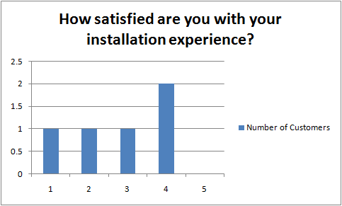
No. | Level of satisfied | Number of Customers
1 | Very Satisfied | 1
2 | Somewhat Satisfied | 1
3 | Neither Satisfied nor Unsatisfied | 1
4 | Somewhat Unsatisfied | 2
5 | Very Unsatisfied | 0

- How satisfied are you with your user experience?
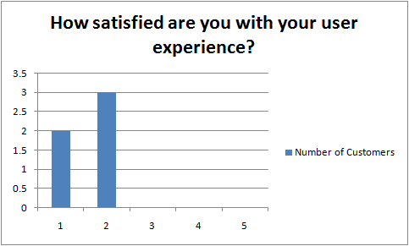
No. | Level of satisfied | Number of Customers
1 | Very Satisfied | 2
2 | Somewhat Satisfied | 3
3 | Neither Satisfied nor Unsatisfied | 0
4 | Somewhat Unsatisfied | 0
5 | Very Unsatisfied | 0

- How satisfied are you with your support experience?
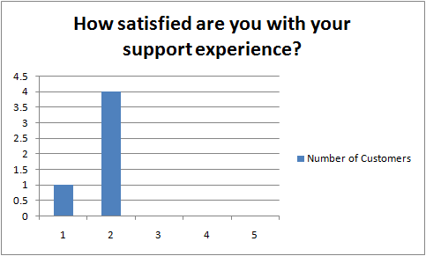
No. | Level of satisfied | Number of Customers
1 | Very Satisfied | 1
2 | Somewhat Satisfied | 4
3 | Neither Satisfied nor Unsatisfied | 0
4 | Somewhat Unsatisfied | 0
5 | Very Unsatisfied | 0

- Overall, how satisfied are you with our software?
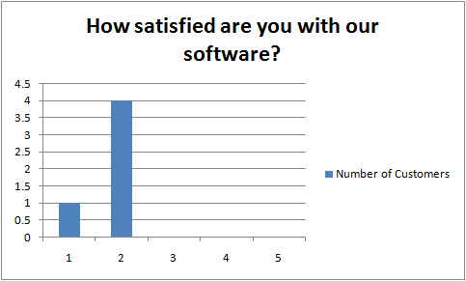
No. | Level of satisfied | Number of Customers
1 | Very Satisfied | 1
2 | Somewhat Satisfied | 4
3 | Neither Satisfied nor Unsatisfied | 0
4 | Somewhat Unsatisfied | 0
5 | Very Unsatisfied | 0

